Meiosis Video

http://www.watchknowlearn.org/Video.aspx?VideoID=56202&CategoryID=7580

1. How many chromosomes do your body cells have? __________________________________________________
(1 mark)

2. Which cells don’t have 46 chromosomes? _____________________________________________________________

_____________________________________________________________________________________________________________
(1 mark)

3. How many chromosomes do they have? _______________________________________________________________

_____________________________________________________________________________________________________________
(1 mark)

4. Why do they have this many? __________________________________________________________________________

_____________________________________________________________________________________________________________
(1 mark)

5. What is the other name for egg and sperm cells? _____________________________________________________

_____________________________________________________________________________________________________________
(1 mark)

6. Why is meiosis called reduction division? _____________________________________________________________

_____________________________________________________________________________________________________________
(1 mark)

7. In meiosis how do the new cells compare to the original? ___________________________________________

_____________________________________________________________________________________________________________
(1 mark)

8. “Mitosis makes us _________________________________”
(1 mark)

9. “Meiosis makes cells that are __________________________________ from one another”
(1 mark)

10. What are cells doing in interphase? ____________________________________________________________________

_____________________________________________________________________________________________________________
(1 mark)

11. How many times does PMAT happen in meiosis? ____________________________________________________
(1 mark)

12. What does homologous mean? _________________________________________________________________________

_____________________________________________________________________________________________________________
(1 mark)

13. Describe crossing over __________________________________________________________________________________

_____________________________________________________________________________________________________________
(1 mark)

14. What has happened by telophase I? ___________________________________________________________________

_____________________________________________________________________________________________________________
(1 mark)

15. How many cells are there by telophase II? ____________________________________________________________

_____________________________________________________________________________________________________________
(1 mark)

16. How many chromosomes in an sperm cell? ___________________________________________________________

_____________________________________________________________________________________________________________
(1 mark)

17. What can cause genetic disorders? _____________________________________________________________________

_____________________________________________________________________________________________________________
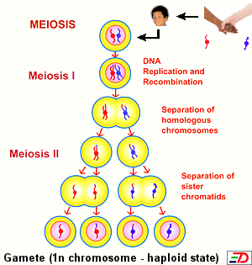
(1 mark)

